DATE: Monday 11 March 2024 Meeting opened: 7.30pm
Location: GVD Office, Bayswater Rd Minute Taker: Brett Wasley

PRESENT: Greg Van Dinter, Lachlan Van Dinter, Paul Southey, Ken Long, Geoff Nicol, Phil Mason, Kerry Cobbing, Lee Williams, Michael Joppick
APOLOGIES: Ty Fielder, Rob Bayne
Guests: NIL
STANDING ITEMS and Discussion |  | Actions
- MINUTES FROM LAST MEETING & MATTERS ARISING:
 | Minutes from last meeting were read.  Matters Arising –  All other items requiring discussion will be raised during the item in this meeting.  Motion: Minutes from last meeting be accepted.  Moved: Goeff Nicol Seconded: Phil Mason | GVD
2. TREASURERS REPORT
 | Financial statements were presented for March 24:  Read by  Previous month Balance $  Bendigo grant: $30,974.53  Bendigo Working: $Increase/ Decrease of $ 1,641.91  Bendigo Debit: $ 103.72 unchanged  Total Bank: $30,974.53 Increase/ Decrease of $1,641.91  Questions from Treasurer.  - Yearly audit still under review.  - Info  - Voting forms for AGM to be sent out soon. 23rd March  Outstanding Bills:  - Australia Post – mail box $174.00 Due 31/03/2024  MOTION: to accept Treasurers report and approve payments of accounts as per transaction report  Moved: Geoff Nicol Seconded: Brett Wasley | Treasurer
3. | Presidents Report  Nothing to repot this month
4. CORRESPONDENCE
 | Inward Correspondence  - 22/02 Funding application from Motorsport Australia – close date 31 May 2024  - Funding area 1: Safety and operational equipment  - Funding area 2: Volunteer Upskilling and club Capacity building  - Funding area 3: Participation Programs  - TY - Draft Khanacross date for Charters Towers  - TY - Resetting of the Khanacross dates from 22-23/04 to 27-28/04  - Ingham Rally Permit returned from MA – Invoice pending.  - MA – Post event fees for Ingham Rallysprint  - Drive-it Cat B Members meeting 13/02  - Website domain bill paid – Ken/kay  - Office of Fair trading - Grievance procedure changes advice.  - MA Safety – new self-extraction requirements  - Winged Seat changes – Ian Gough  - CQMSC – AGM 13/02 & Bitumen Motorkhana 24/02  - Complete Tag Solutions – advertising  - Eventsured – advertising (I think)  Outward Correspondence:  Motion: to accept and respond to inward correspondence.  Moved: Seconded: | Done  Geoff Nicol  Greg Van Dinter
4. MEMBERS
Current Financial members: 94
New member applications – Nil
Competitive members

Social Memberships

MOTION: To accept new members into the club.
Moved: Seconded:
5. CLUB CAPTAINS REPORT
- Nothing to Report
PAST EVENTS
COMING EVENTS
1) | - Hillclimb event permit paid.
2) | - Khanacross
3) | - 18-19 May Rally sprint Charters Towers
4) | - 03rd August Ingham Forest Rally  - 07-08th September Kennedy North (TBA)
6. VENUE UPDATES
Drive- IT Manton Park
- No move due to rain.
- Phil gave an update on the Drive-It functions/directions
- Need to look at possible grants to develop Drive-It facilities including the track.
Charters Towers Milchester Park
- No movement due to rain.
- TY may have acquired a Tractor to clean the track.
Victoria Park Clubrooms
- Roof ordered, ready to fit, awaiting weather to clear.
- All documentation completed.
7. SAFETY
 | - MA released the new requirements for exiting the vehicles.
7. GENERAL BUSINESS
1) | - Application for Khanacross email disappeared from email address.  - Be aware that emails may go missing – check email folders. | GN
2) | - Trailer for a water tank to be delivered to Charters Towers. Will be fitted with water pumps to spray for track maintenance. | PS
3) | - Drive-it needs to be sorted to attract younger people to the sport.  - Need to setup motorkhana pad.  - Possible ability to run separate session with learners at one end v experiences people at a different section.  - Look at a "learn to Drive/Motorkhana" event.
4) | - Does the club want to run food for events at Drive-It?  - Time is thin for everyone.
5) | - Hillclimb – min. 12 cars to run. Will cancel the event if not 12 cars.  - As at 11/03 – 6 entries. Wednesday close of entries – decision made then.  - Need to look at resetting the pricing for the event. | Kerry
6)
7)
9)
 | MEETING CLOSED: 8:41 pm
 | NEXT MEETING: Mon 08 April 2023 at 7.30pm

Self-extraction requirements

Ensuring safety - new self-extraction requirements in 2024 and 2025

All Motorsport Australia licenced competitors will be required to self-extract from their vehicles in 10 seconds or less from 2025 and beyond, with a 15 second limit in 2024.
In line with advice from the Motorsport Australia Risk and Safety Committee, and FIA standards, the phased introduction will provide competitors with the opportunity to practice the best way to self-extract themselves from their vehicles before being tested at events.
In 2024, competitors will initially be required to self-extract in 15 seconds as part of a staged introduction of the new requirement, before the 10 second limit is mandated on 1 January 2025.

KEY POINTS TO NOTE

- From 1 January 2024, competitors will be required to be able to self-extract from their vehicle within 15 seconds
- From 1 January 2025, that limit will reduce to 10 seconds as part of our phased introduction of this requirement
- Tests will be conducted at events throughout 2024
- Competitors may be required to complete the test more than once if the competitor competes in different vehicles

This requirement will not apply to those competitors competing in categories that already have a shorter extraction time listed in their regulations, with the lesser time taking precedence.
Motorsport Australia has implemented the requirement to ensure competitors are trained and ready if they are required to self-extricate during an emergency situation.
A number of tests were conducted at events across disciplines in 2023, with competitors tested averaging well below the 10 second requirement.

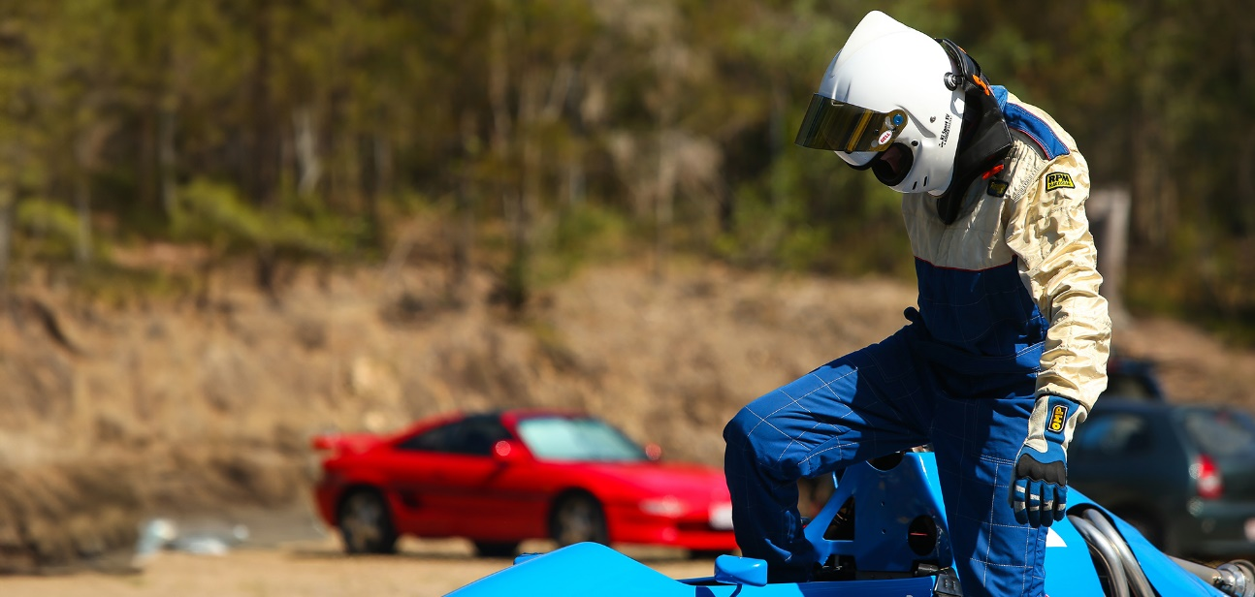

The ability to self-extract from a vehicle is an important part of motorsport safety in line with international guidelines being used around the world. This is important as in the event of a serious incident time is crucial. The tests conducted at events around Australia in 2023 saw competitors average well below 10 seconds, highlighting that for most competitors this will not be a significant challenge. For example, at a state circuit racing event where competitors were tested this year, the average time of self-extraction was 8.45 seconds, and the slowest time recorded was 11 seconds.
Like anything, the more practice competitors get at self-extraction, the better they will become. This is also something people can practice at home or at the workshop without adding any additional testing costs, as competitors need to belt themselves in wearing full race gear and practice the best way to exit the vehicle.
When it comes to fire and other leaks or issues, a quick self-extraction is key to surviving and minimising or preventing serious injury. Practicing self-extraction will provide some muscle memory and improved reaction times that competitors can rely on should they ever find themselves in an emergency situation.
Our officials and staff will be very happy to work with those who may not initially be able to meet this goal to ensure they can understand how to meet the requirement and self-extraction requirements.
For more information and a list of frequently asked questions around the change, head to motorsport.org.au/selfextraction

